Tutorial 08 Advanced Sort Quick Sort

1. Using Quick Sort binary tree, trace the execution of quick sort with the following list of numbers, and using the first element of the list/subsists as the pivot value:
   1. 4, 7, 1, 8, 3, 2, 6, 5 (in ascending order)
   2. 5, 2, 7, 8, 1, 4, 6, 3 (in descending order)

**Part A:**

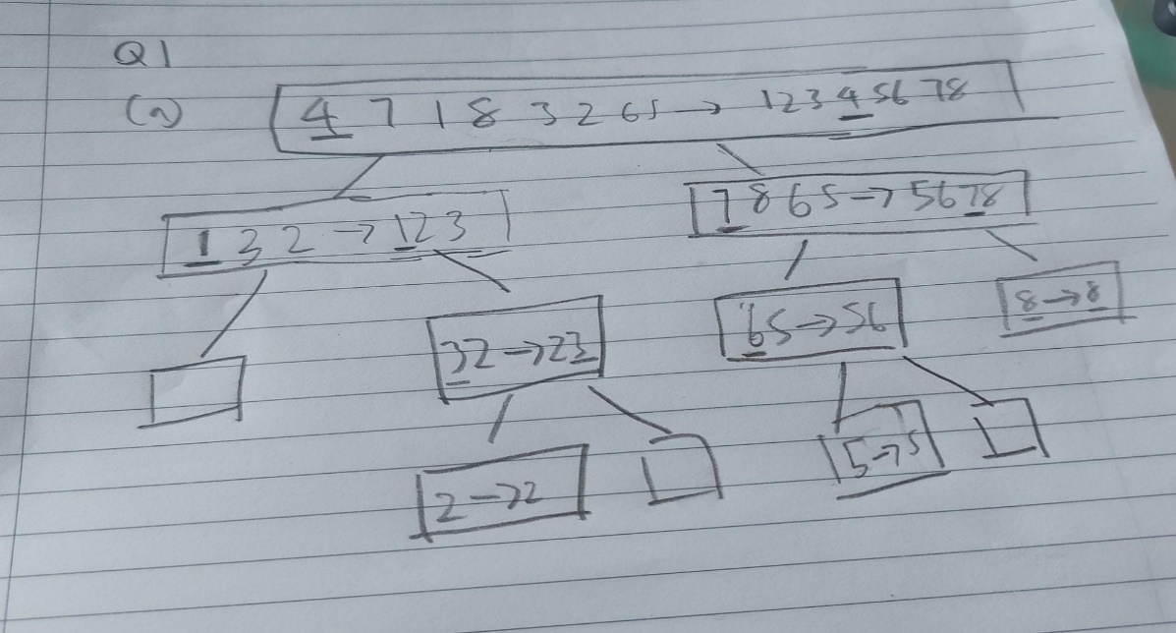

**Part B:  
